Delegation Report - Sumba April 2012.
As I sit down in my comfortable chair, I have my finger poised over the keyboard, and my mind reminisces over the recent trip to Sumba. The first things that come to mind – the rice, the standard of living, the language, the smell, the walking, the riding, the sleeping, the mosquitoes, the chickens, the lizards, the water, the heat, the green tropical jungle, the cute children, red beetle nuts, the toilets, the punctuality (NOT), the stories.
However, most of you have heard the usual story – a naive member of the mission committee accompanies Papa Brian to Suma, totally underestimates what to expect, and is ‘shocked’ at what they experience. Often a trip on the mission field is humbling, and almost makes us feel guilty of what we have when compared to our brothers and sisters in Sumba.
I do not wish to retell my entire journey – most of it has been said before, and it is difficult to put a new slant on these trips. However, instead of telling of what I did and experienced, I would love to relay to you the lasting memory that lives with me, that stays with me and something that cannot be explained too many times. This is the memory – our Almighty Father’s preservation and expansion of the church, the Holy Catholic Christian Church in a remote, poor island of Sumba.
Like many of the members in the supporting churches of Rockingham and Baldivis, I have always had an interest in the mission work in Sumba, even ‘holidaying’ in Sumba many years ago for a couple of nights. I am a member of the mission committee, making decisions that affect the mission field over distant seas. However, I soon realized how little I knew of what happened on this island. It took one afternoon on the island with Papa Brian to realize that I knew very little, and I opened my note book, and from the beginning, mapped the progress of the mission field. I would like to share with you how the mission field started, and would like to give you a snapshot of how things have progressed.
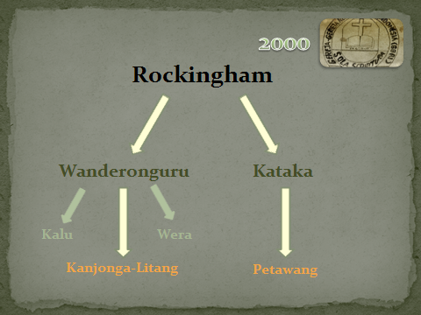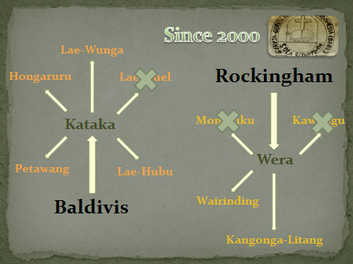
Figure 1: Chart of mission project at the beginning (left), and currently (right)
The Free Reformed Church of Rockingham entered the mission field on the island of Sumba some 10 years ago. Initially it supported 2 mission posts through 2 supporting churches. In the past 10 years, the Baldivis church was instituted, and it was decided that it would support the mission post of Petawang through the supporting church of Kataka, and Rockingham would continue to work in the mission post of Kanjonga-Litang through the church of Wanderonguru, then later through Wera.
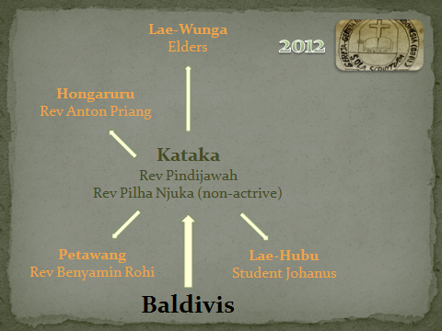
Figure 2: Baldivis mission project as of 2012
Through Kataka, the number of mission posts has grown over 10 years from the original post of Petawang, to now include Hongaruru, Lae-Wunga, Lae-Hobo. It is marvellous seeing the mission project expand through the church of Kataka. The ‘first’ mission post of Petawang is still being served by Rev Benyamin Rohi. Another of the mission posts – Hongaruru, recently decided that it will instituted in 2015 D.V. This is exciting news for this congregation. It means that this mission posts has a paster (Rev Anton Priang), enough men in the church suitable for the offices of elder and deacon, collects enough to support its minister, and has a mission post of its own (Lae-Wunga). God is richly blessing the work of the minister, the efforts of the Sunday school teachers, and also the witnessing of the congregation. This mission post (Hongaruru) runs several Sunday school programs, one of them is intentionally located in a heathen area, which currently has approx 70 heathen children attending!! They hope that through this, the parents will come to church.
One of the mission posts - Lae-Wunga is situated in a remote part of the island, and has not been visited by any of the mission delegates until now. This mission post is a year old, with no baptised members, but many locals attending church. They have built a church from their own funds, and have a reading service every week from one of the elders of Hongaruru. And when I say remote, I mean remote. Papa Brian decided that it would be good for us as delegates to experience what they experience, and walk to this mission post from Hongaruru – it is not possible for any vehicle or motorbike to get to this village. I would not consider myself in bad shape, so walking the 25km return trip to this village seemed reasonable. But I soon realized that the people of Sumba are very fit, shorter and lighter than myself, and have a greater resistance to the heat and humidity by wearing jumpers for the entire journey! We were accompanied on this hike by some of the elders that regularly preached in this village. This trek to the village was mostly flat for the first 10km, with only a few creek crossings, 35 degree weather, long grass above my head, or short Spinifex whipping my ankles. Remember, this walk was done on thongs, and this was not at Sumbanese pace, but rather a Bosveld pace! Once we arrived at the start of the decent at the 10km mark, the novelty had worn off, and fatigue was setting in. However, I was happy to finally decent the mountain toward the village. We could see the village, snuggled between luscious green mountains. The path down the mountain, through the jungle was very muddy and mostly blocked with fallen trees and overgrown creepers. I was as excited to see a place to rest and relax, as the villagers were excited to see us. The journey usually takes the local 4 - 4 ½ hours each way, but Brian was determined to get there quicker than what they did, it took us approx 3 ½ hours. Once we reached the bottom, we were greeted by the smiling face of approx 30 locals, most that were attending church. We had a look at the newly built church building, and then visited the chief of the village for some lunch. Again, we had rice and chicken. Brian even had time to play chess with the locals – this seems to be a custom whenever Brian is around!
I was looking forward to getting back ‘home,’ but the trip up the mountain was daunting. When I was told that we would take a shortcut home, I was thankful, but a little confused why we did not take that ‘shorter’ route coming in. All was made very clear as we began to ascend the mountain. The 2km trudge up the mountain was extremely tough for me with my larger frame! I had to stop several times in order to catch my breath. The muddy path was about 30cm wide, my thongs very slippery from mud and sweat, and there was a steep cliff below and above me. Getting to the top of the mountain was honestly one of the toughest things I have ever done. The way back seemed easier, knowing what to expect. However, both Brian and I suffered from rashes and blisters on both our feet. In the final few km, Brian found it necessary to change thongs with those walking with us as his thongs were unbearable. After walking in Brian’s thongs for 500m, I could not agree more. Hats off to you Brian for walking 25km on the worst thongs know to man!
This hike to this mission posts will long burn in my memory – it was an experience, albeit difficult. The effort that the elders of Hongaruru put in every week to preach the Word to this mission post proves to me that they have a deep desire to serve God, and spread the good news to those around them. The elder leave Hongaruru on Saturday afternoon to preach the Word, and return Sunday evening – a 24 hour round trip to read a sermon and share fellowship with people that yearn to have the gospel preached to them.
We also had the opportunity to go to another new mission post - Lae-Hobo. To get to this mission posts, I was required to ride with Brian on the back of his motor bike for 3 ½ hours. The ride was terrible, with pot holes; fallen trees, roads washed away, cows, and people hindering our progress. I was very glad to get to Lae-Hobo – a chance to stretch and meet the locals. At this mission post, 13 adults were baptised (plus children) recently. They also will be receiving an evangelist in the next 6 months once a house is built for him.
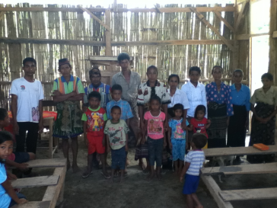
Figure 3: Some member of the Lae-Hobo mission post that recently did profession of faith,
with the evangelist Johanus on the far left of picture
Overall, I was very impressed with the evangelism work done through the church of Kataka. The zeal, desire and determination to spread the Good News, regardless of the effort required, were both a joy and a pleasure to witness. To God is the glory!
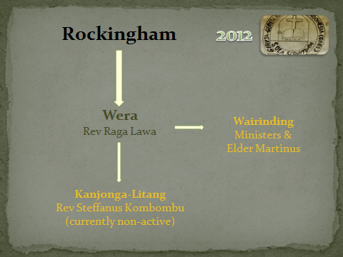
Figure 4: Rockingham mission project as of 2012
The church of Rockingham retained the other mission post of Kanjonga-Litang through the supporting church of Wera. Towards the middle of last year, Rev Stefanus Kombombu was involved in a serious motorbike accident. As a result of this accident, he has not been serving in his task as minister of that mission post, currently listed as ‘non-active’ due to the headaches and bleeding that he has been experiencing. He has been to the doctors in Sumba, but they are unable to identify the reasons for his ongoing lack of health. In April, he was granted permission to see specialists in Bali, hoping to diagnose the problem, and return to work in the near future.
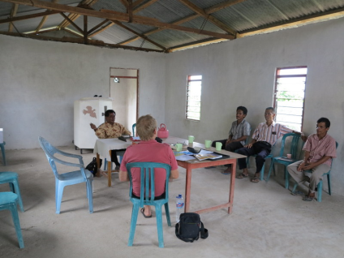
Figure 5: Meeting with the Wera consistory
We also had the opportunity to visit the newest of all mission posts - that of Wairinding, situated in West Sumba. We visited this mission post on Sunday, and shared fellowship with them including lunch. There is one family, and elder from the church at Wera that lives here and he leads the services most weeks.
The mission post of Kanjonga-Litang was a disappointment for me, due largely to the fact that Rev Stefanus Kombombu was ill, and suffering from the effects of the accident. I have not been to this mission post when Rev Stefanus Kombombu was healthy and fit, and reserve my opinion until he has regained full health. It is a sad thing to see a minister, who from all reports had much zeal and energy in God’s service, become a quiet and subdued pastor. Let’s pray that in due time, he may regain his health, and re-commence his task as shepherd of the flock, to the glory of God’s name.
When looking at the work done through the 2 supporting churches of Kataka and Wera, we have many reasons to praise and glorify God for His care over the church, and the furtherance of His kingdom. The work of our churches here, many miles from the island of Sumba, assists them advancing the gospel. Through the consistories and the mission committee, we have regular visits and correspondence with the churches and mission posts in Sumba, assisting and advising them with their work.
We can praise God that the work of mission, spreading the Good News of the forgiveness of sins through faith in our Lord Jesus Christ may continue also through the support we give. God expects from us to be busy with this work and we thank God for bringing people to faith and pray that many more may respond to the gospel believing in Him.

